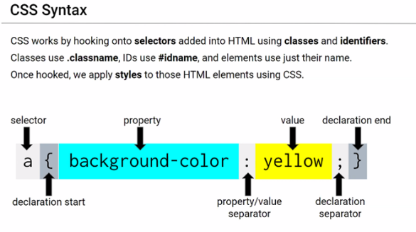CWRU – CLASS NOTES 8-10-2020 6:30pm EST.

Trilogy

DAY 3: Lesson 1.1

**08-15-2020**

**Beyond Compare (Refactor)**

**Getbootstrap.com**

**Cs3school.com**

**CSS – HEREO**

* **CASTCATING STYLE SHEET**
* **LIKE WRIGHTING PAPERS IN WORD**

**HTML**

* **HYPERTEXT MARKUP LANGUAGE**
* **WRIGHTING IN NOTEPAD**

|  |  |  |  |  |  |  |  |
| --- | --- | --- | --- | --- | --- | --- | --- |
| **CSS** | | | | | | | |
|  | **selector** | **Example** | **Priority** | **Example of selector used** | **How to use** | **Applies** | **Needs** |
| 1 | ELEMENT | P, A, DIV, SPAN | Lest priority | P { background-color: blue; } | To all | To all | nothing |
| 2 | CLASSES | .MYDIV, .PHONENUMBER | 2nd priority | .classItem { background-color: orange; } | To groups | All Elem. w/ .class=” classitem” | **.** |
| 3 | I.D.. | #MYDIV, #PHONENUMBER | 1st priority | #idItem { background-color: green; } | To specific | Elem with id=”iditem” | **#** |

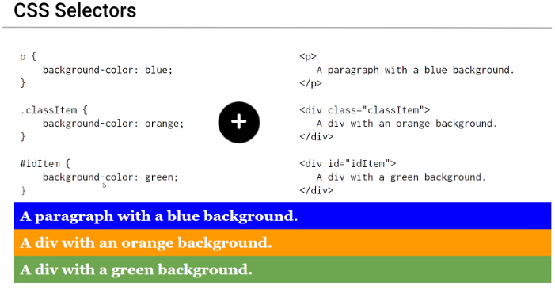

**Relative Fie Paths (always use)**

* Relative files paths connect us with other files in our working directory. In this case, style.css is in the same folder as our html document

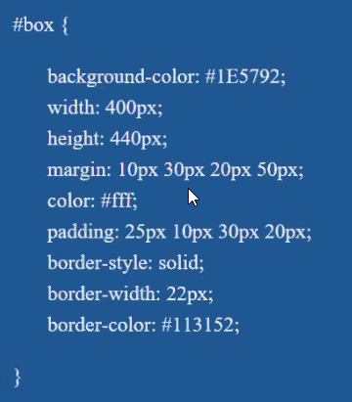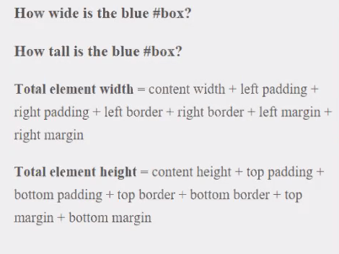**Absolute paths ( never use)**

* Has critical info to the required files

**Host**

* Putting it on the internet

1. link rel="stylesheet" type="text/css" href="css/style.css"
2. link rel="stylesheet" type="text/css" href="assets/style.css"
3. link rel="stylesheet" type="text/css" href="assets/style/style.css"
4. link rel="stylesheet" type="text/css" href="assets/style.css"
5. link rel="stylesheet" type="text/css" href="../style.css"
   1. Back into a folder
6. ink rel="stylesheet" type="text/css" href="../../style.css"
   1. Back 2 folders

Boxes

* 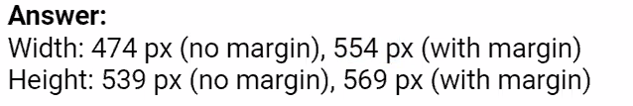Basic for webpages
  + Inspect a webpage
    - Front end development
* Activity: Box model

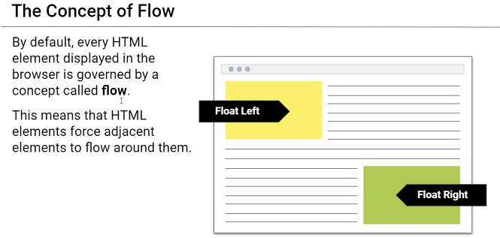The Concept of flow

* Snap
* Block elements

Block Elements vs. In-line Elements

Floatss

Clearing the Floats

* Clear fix
* Clear fix hack

